**Stock Movement Analysis Based on Social Media Sentiment**

# Visualization and Reporting

The analysis includes a bar plot showcasing the frequency of mentions for various stock-related keywords. Key elements of the visualization are as follows:

* **X-Axis:** Displays keywords or trends.
* **Y-Axis:** Represents the frequency of mentions.
* **Bars:** Heights correspond to keyword frequencies, with annotated values for clarity.
* **Title:** Highlights the focus of the analysis.

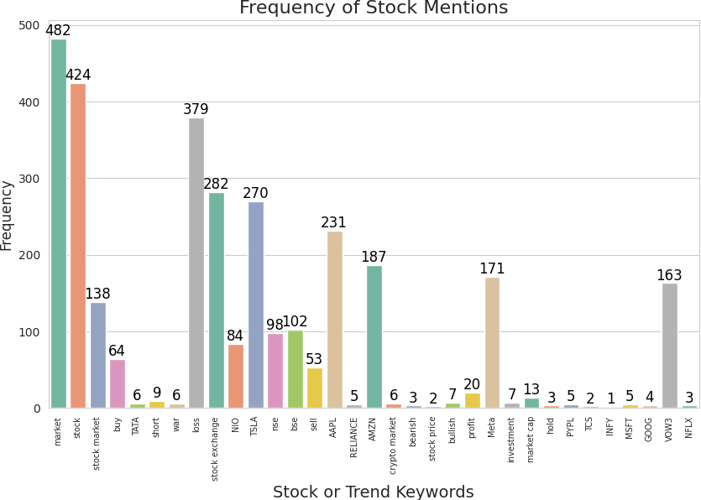

# Stock-Specific Inferences

**AAPL (Apple Inc.)**

* **Correlation Matrix:**
  + Price Change vs. Polarity: 0.027
  + Price Change vs. Mention Count: 0.016
  + Polarity vs. Mention Count: -0.03
  + **Inference:** Weak correlations among variables.

**Key Observations:**

* + **Stock Price:** Fluctuates daily, indicating instability.
  + **Sentiment Polarity:** Mixed, with significant variations from mid-2024.
  + **Mention Count:** Periodic spikes in public attention.

**TSLA (Tesla, Inc.)**

* **Correlation Matrix:**
  + Price Change vs. Polarity: -0.00094
  + Price Change vs. Mention Count: 0.039
  + Polarity vs. Mention Count: -0.031
  + **Inference:** Minimal relationships among variables.
* **Key Observations:**
  + **Stock Price:** Highly volatile, no clear trend.
  + **Sentiment Polarity:** Mixed public reactions, notable variability.
  + **Mention Count:** Peaks during specific events.

**Other Stocks (GOOG, MSFT, AMZN, TCS, NFLX, PYPL, NIO)**

For these companies, the findings highlight:

* **Stock Price:** High volatility with no consistent trends.
* **Sentiment Polarity:** Mixed reactions, fluctuating throughout the year.
* **Mention Count:** Periodic spikes, indicating significant public or media attention.

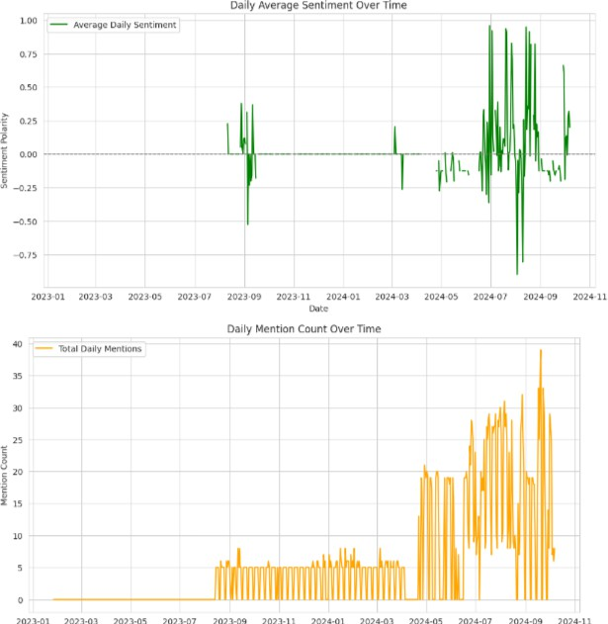

# General Observations

1. **Daily Average Sentiment:** Fluctuates significantly around zero, reflecting mixed public sentiment.
2. **Mention Count Over Time:** Peaks around mid-2024, signifying increased attention during specific periods.

# Report Findings and Recommendations

**Buy/Sell Signals by Stock:**

* **AAPL:** Buy during high public attention and positive sentiment; sell during negative sentiment phases.
* **TSLA:** Buy after positive sentiment spikes; sell during dips in sentiment.
* **GOOG, MSFT, NFLX, PYPL, TCS, NIO:** Similar strategies based on positive sentiment peaks and negative sentiment dips.

**Recommendations:**

1. **Data Integration:** Combine insights from financial reports, market analyses, and news articles.
2. **Advanced Analysis:** Employ machine learning and NLP for enhanced accuracy, incorporating context-aware sentiment analysis.
3. **Real-Time Monitoring:** Enable real-time insights for dynamic decision-making.
4. **Cross-Market Trends:** Investigate correlations across different markets for comprehensive patterns.

# Future Improvements

* Expand sentiment analysis capabilities with advanced algorithms.
* Leverage multi-source data to deepen analysis.
* Transition to real-time dashboards for actionable insights.

This structured approach offers traders and analysts actionable insights derived from social media sentiment and its influence on stock movements.